N
Tiffany Wickliffe | 12550 Willow Tree Avenue  Moreno Valley, California  (951)581-4550  Wheattiff@gmail.com
EXPERIENCE  Moreno Valley, California — Substitute Teacher  April 2006 - PRESENT  EDUCATION  Grand Canyon University, Online - Masters Elementary Education  October 2019  California State University Dominguez Hills, Carson, California — Bachelor’s in Human Resources  June 2005  Compton Community College, Compton, California — Associates in Arts, Associates in Science  June 2002-2003  PROJECTS  Teen Mothers’ Community Mentor Leader- 3 years  Motivational Speaker building self-efficacy.  Guides Students.  Organizes fundraiser campaigns.  Dedicates time to struggling moms.  Committed to supporting students yearly.  Black History Month Coordinator — 10 years  Responsible for working with students before and after school.  Fundraiser campaigns.  Checks in monthly for focus groups and brainstorming.  Volunteers times.  Plans organize and funds students’ activities.  Build bridges with staff and other stakeholders to support scholars.  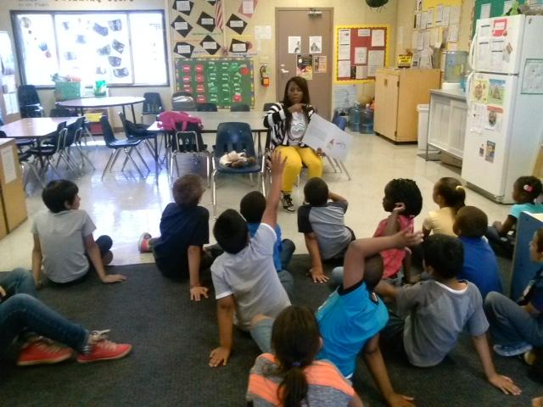 | SKILLS  - Plans lessons and extension activities.  - Does Formal and informal assessments.  - Uses collective efficacy  - Mentors scholars working one on one.  - Adaptability and flexible adding engaging instruction.  - Provides opportunities for parent Involvement.  - Creates ways to make learning meaningful.  - Teaches from the heart to build lifetime bridges with learners.  - provides learners with ways to use real-world thinking.  - Follows learning environments routines and procedures.  - Maintains privacy and culturally responsive teaching.  AWARDS  Volunteer Tea Award 2017-19  LANGUAGES  English

